**Ideation Phase**

**Brainstorm & Idea Prioritization Template**

|  |  |
| --- | --- |
| Date | 19 September 2022 |
| Team ID | PNT2022TMID04471 |
| Project Name | Project - News Tracker Application |
| Maximum Marks | 4 Marks |

**Brainstorm & Idea Prioritization Template:**

Brainstorming provides a free and open environment that encourages everyone within a team to participate in the creative thinking process that leads to problem solving. Prioritizing volume over value, out-of-the-box ideas are welcome and built upon, and all participants are encouraged to collaborate, helping each other develop a rich amount of creative solutions.

Reference: [https://app.mural.co/t/ibm6012/m/ibm6012/1666285440043/570429885404a188236614b8672c97 985bc04734](https://app.mural.co/t/ibm6012/m/ibm6012/1666285440043/570429885404a188236614b8672c97985bc04734)

**Step-1: Team Gathering, Collaboration and Select the Problem Statement**

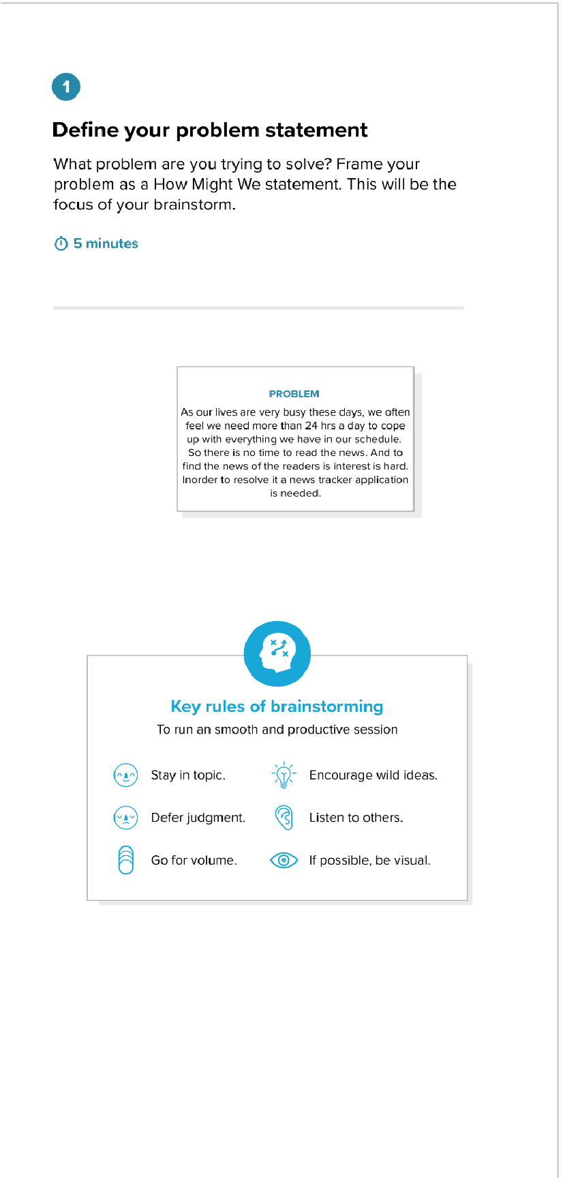

# Step-2: Brainstorm, Idea Listing and Grouping

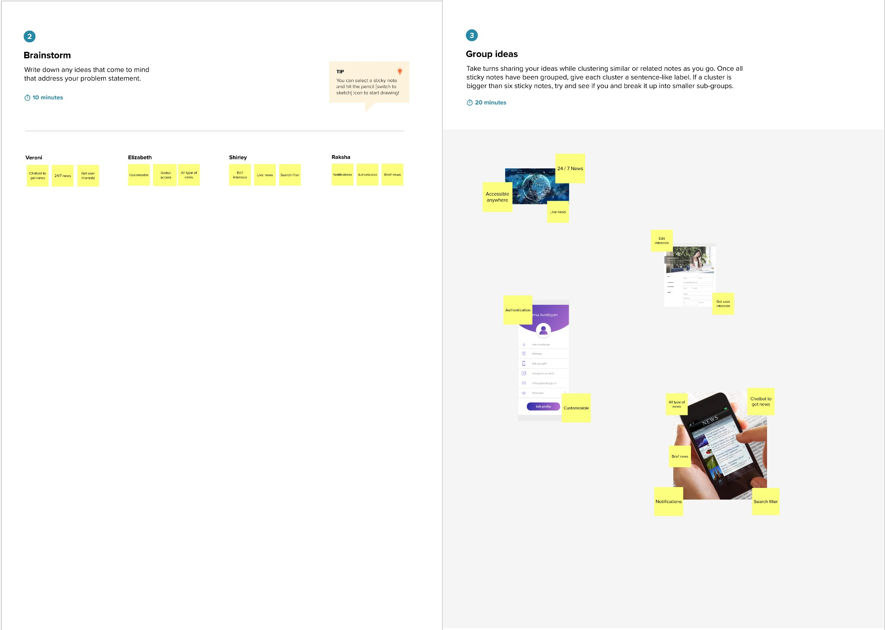

# Step-3: Idea Prioritization